**ARRAYS**

**ASSIGNMENT # 4**



**Spring 2019**

**CSE102 Computer Programming**

Submitted by: **Shah Raza**

Registration No. : **18PWCSE1658**

Class Section: **B**

“On my honor, as student of University of Engineering and Technology, I have neither given nor received unauthorized assistance on this academic work.”

Student Signature: ______________

Submitted to:

**Engr. Madiha Sher**

March 3,2019

Department of Computer Systems Engineering

University of Engineering and Technology, Peshawar

## Objectives:

To understand the syntax of array, declaration, assignment and initialization

To learn to write programs to model repetitive data using arrays

**TASK #1:**

Write a program that takes an integer array of size 10 form the user and displays how many times integer 5 appears in it.

**Code:**

#include <iostream>

using namespace std;

int main()

{

const int SIZE=10;

int A[SIZE],counter=0;

cout<<"Enter an Array: ";

for(int i=0;i<SIZE;i++)

{

cin>>A[i];

}

for(int i=0;i<SIZE;i++)

{

if(A[i]==5)

counter++;

}

cout<<"No of 5 (s) in this array: "<<counter;

return 0;

}

**Output (Compilation, Testing and Debugging):**

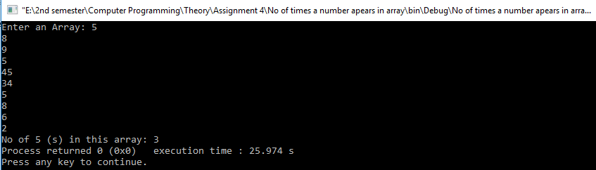

**TASK #2:**

Write a program that displays

* How many numbers in the above array (task 1) are greater and less than 5.
* The program should also display the minimum and maximum values in the array.

**Code:**

#include <iostream>

using namespace std;

int main()

{

const int SIZE=10;

int A[SIZE],Min,Max,Greater=0,Less=0;

cout<<"Enter an Array: \n";

for(int i=0;i<SIZE;i++)

{

cin>>A[i];

}

for(int i=0;i<SIZE;i++)

{

if(!i)

{

Min=A[i];

Max=A[i];

}

if(A[i]>Max)

Max=A[i];

if(A[i]<Min)

Min=A[i];

if(A[i]>5)

Greater++;

if(A[i]<5)

Less++;

}

cout<<"Min: "<<Min;

cout<<"\nMax: "<<Max;

cout<<"\nNo of elements that are Greater than 5: "<<Greater;

cout<<"\nNo of elements that are Less than 5: "<<Less;

return 0;

}

**Output (Compilation, Testing and Debugging):**

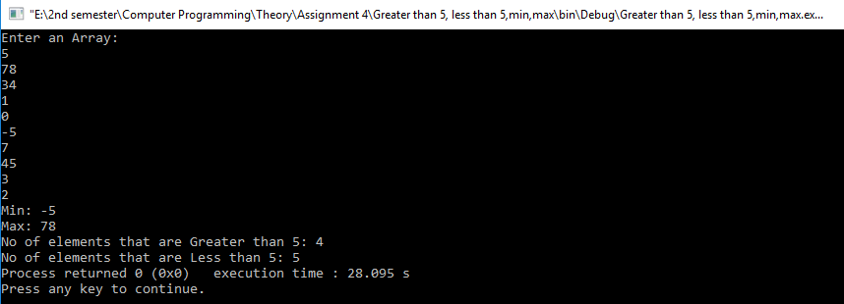

**TASK #3:**

Write a program that reads two integer arrays as input from user and displays their:

* Sum
* Dot Product

**Code:**

#include <iostream>

using namespace std;

int main()

{

const int SIZE=5;

int A[SIZE],B[SIZE],sum[SIZE],prod[SIZE];

cout<<"Enter the first Array: ";

for(int i=0;i<SIZE;i++)

cin>>A[i];

cout<<"Enter the second Array: ";

for(int i=0;i<SIZE;i++)

cin>>B[i];

for(int i=0;i<SIZE;i++)

sum[i]=A[i]+B[i];

for(int i=0;i<SIZE;i++)

prod[i]=A[i]*B[i];

cout<<"Sum = ";

for(int i=0;i<SIZE;i++)

cout<<sum[i]<<" ";

cout<<"\nProduct = ";

for(int i=0;i<SIZE;i++)

cout<<prod[i]<<" ";

return 0;

}

**Output (Compilation, Testing and Debugging):**

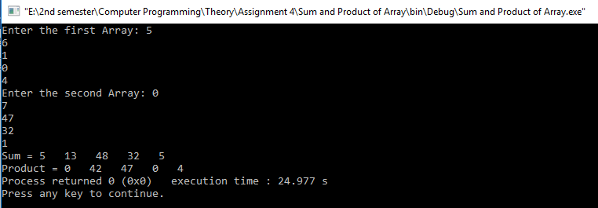

**TASK #4:**

Write a program that takes a long string from the user (size should be greater than 30) and displays the number of characters, and number of words in it. Here is a sample run.

**Code:**

#include <iostream>

#include <stdio.h>

using namespace std;

int main()

{

const int SIZE=100;

int characters=0,words=1;

char A[SIZE];

cout<<"Enter a string: \n";

gets(A);

for(int i=0;A[i]!='\0';i++)

{

characters++;

if(A[i]==' ')

words++;

}

cout<<"No of characters: "<<characters;

cout<<"\nNo of Words: "<<words;

return 0;

}

**Output (Compilation, Testing and Debugging):**

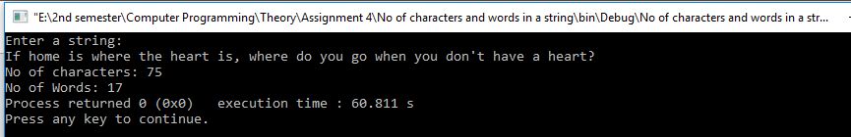

**TASK #5:**

Reads a sentence and prints frequency of each of the vowels and total count of consonants.

**Code:**

#include <iostream>

#include <stdio.h>

using namespace std;

int main()

{

const int SIZE=100;

char A[SIZE];

int a=0,e=0,i=0,o=0,u=0,consonants=0,specialch=0;

cout<<"Please enter a string: ";

gets(A);

for(int c=0;A[c]!='\0';c++)

{

if(A[c]=='a'||A[c]=='A')

a++;

else if(A[c]=='e'||A[c]=='E')

e++;

else if(A[c]=='i'||A[c]=='I')

i++;

else if(A[c]=='o'||A[c]=='O')

o++;

else if(A[c]=='u'||A[c]=='U')

u++;

else if((A[c]>=0 && A[c]<=64)||(A[c]>=91 && A[c]<=96)||(A[c]>=123 && A[c]<=127))

specialch++;

else

consonants++;

}

cout<<"Frequency of vowels: \n";

cout<<"A: "<<a<<endl;

cout<<"E: "<<e<<endl;

cout<<"I: "<<i<<endl;

cout<<"O: "<<o<<endl;

cout<<"U: "<<u<<endl<<endl<<endl;

cout<<"Consonants: "<<consonants;

return 0;

}

**Output (Compilation, Testing and Debugging):**

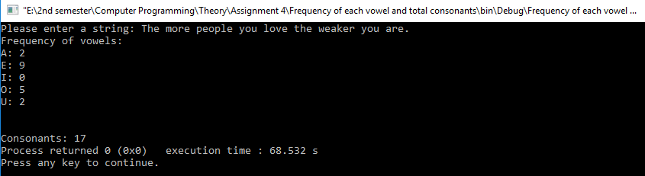

**TASK #6:**

Write a program to read a string and check for palindrome without using string related function (a string is palindrome if its half is mirror by itself eg: abcdcba).

**Code:**

#include <iostream>

using namespace std;

int main()

{

const int SIZE=20;

char A[SIZE];

int i=0;

cout<<"Enter a String: ";

cin>>A;

for(;A[i]!='\0';i++); //Size of string

int half=i/2;

int a=0;

for(;a<half;a++)

{

if(A[a]!=A[--i])

break;

}

if(a==half)

cout<<"This string is palindrome";

else

cout<<"This is not a palindrome";

return 0;

}

**Output (Compilation, Testing and Debugging):**

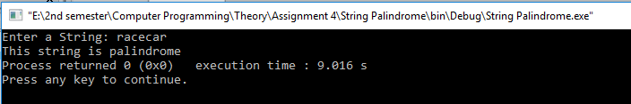

**TASK #7:**

Write Develop, implement and execute a program that reads two matrices A (m x n ) and B (p xq) and Compute the product A and B. Read matrix A in row major order and matrix B in column major order. Print both the input matrices and resultant matrix with suitable headings and in matrix format. Program must check the compatibility of orders of the matrices for multiplication. Report appropriate message in case of incompatibility.

**Code:**

#include <iostream>

using namespace std;

int main()

{

int m,n,p,q;

cout<<"Enter no. of rows and columns for Matrix A: ";

cin>>m>>n;

cout<<"Enter no. of rows and columns for Matrix B: ";

cin>>p>>q;

int A[m][n],B[p][q],C[m][q];

if(n!=p)

cout<<"Matrix multiplication no possible";

else

{

cout<<"Enter Matrix A: \n";

for(int i=0;i<m;i++) // Input A

{

for(int j=0;j<n;j++)

cin>>A[i][j];

}

cout<<"Enter Matrix B: \n";

for(int i=0;i<p;i++) //Input B

{

for(int j=0;j<q;j++)

cin>>B[i][j];

}

for(int i=0;i<m;i++) //Multiplication process

{

for(int j=0;j<q;j++)

{

int sum=0;

for(int k=0;k<n;k++)

{

sum=sum+A[i][k]*B[k][j];

}

C[i][j]=sum;

}

}

cout<<"Matrix A: \n";

for(int i=0;i<m;i++) //Output A

{

cout<<"| ";

for(int j=0;j<n;j++)

{

cout<<A[i][j]<<" ";

}

cout<<" |\n";

}

cout<<"Matrix B: \n";

for(int i=0;i<p;i++) //Output B

{

cout<<"| ";

for(int j=0;j<q;j++)

{

cout<<B[i][j]<<" ";

}

cout<<" |\n";

}

cout<<"Multiplication Result: \n";

for(int i=0;i<m;i++) //Output C

{

cout<<"| ";

for(int j=0;j<q;j++)

{

cout<<C[i][j]<<" ";

}

cout<<" |\n";

}

}

return 0;

}

**Output (Compilation, Testing and Debugging):**

